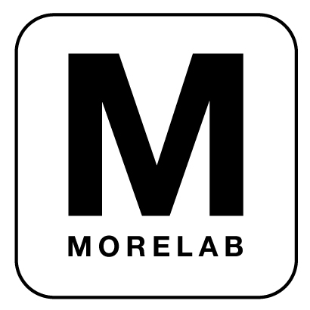
MoreLab Apprenticeship Program 2016
001. Description

A few times a year, MoreLab offers a limited number of unpaid apprenticeships across a range of disciplines, including art, design, fabrication and social activism. Though we do look for specific skills when filling specific apprentice positions, we are more interested in more intangible qualities and capabilities, such as your passion, your ability to thrive under diverse and dynamic creative working conditions and your receptiveness to subverting the existing categories and hierarchies that define your area of disciplinary training. Because we receive far more applications than we can accommodate, these apprenticeships tend to be competitive, challenging and extremely rewarding opportunities for both creative and personal growth.

Each January, May and September, MoreLab accepts 2 to 3 qualified candidates as MoreLab Apprentices. Apprentices can be in any stage of their art, activism or design career, from students to practicing professionals. Apprentices are assigned a role and a MoreLab mentor at the start of their time with MoreLab, but depending on skills and interests, the position can evolve over time. Often all Apprentices are called to participate in charrettes, brainstorming sessions and project expeditions to exotic locales around the world.

Apprentice make a 12-week commitment of at least 10 hours per week with at least one day per week spent at the MoreLab studio in West Oakland, the global heart of larg-scale industrial artmaking. While there is currently no monetary compensation for apprenticeships, available benefits include the potential for academic credit, extraordinary and invaluable experience conceiving and executing art and design projects, meeting and collaborating with talented art/design practitioners and recognition on MoreLab’s website. Additional perks often include field trips and use of shop facilities for personal projects. Though we are flexible, we ask that you commit to a regular routine and map out the schedule for your overall time with us so that we’re aware of your academic deadlines, vacations and other commitments prior to the commencement of your apprenticeship.

To apply for an Apprentice position, email these materials to: apprentice@morelab.com

- A brief letter of inquiry telling us who you are, what you hope to achieve during your time with us, any academic requirements you are trying to fulfill.
- A completed Apprentice Application and Evaluation form.
- A recent CV or resume.
- A link to a website or an electronic copy of your portfolio of work.

Thank you for your interest in MoreLab. We look forward to hearing from you!

MoreLab is an equal opportunity collaborator and does not select its apprentices based upon race, ethnicity, religion, gender, age, sexual orientation, gender identity or any other category irrelevant to making art and design projects.

MoreLab Apprenticeship Program 2016
002. Positions

Artwork Fabrication Apprentice (1)
Supervisor: Elizabeth Marley
Skills: Familiarity with shop tools, experience with craft/materials (wood, metal, etc.)
Responsibilities:
- Test and develop working versions of projects under construction in MoreLab’s shop
- Create physical models as needed for design development
- Help manage and maintain MoreLab’s shop and tools, advise and research new purchases
- Develop new technologies, prototypes, physical designs and experiments with direction from MoreLab artists.

Design Apprentices (1-2)
Supervising Principals: Elizabeth Marley, Matthew Passmore
Skills: Adobe CS, Autocad, Rhino, Solidworks, Revit, other 3D modeling platforms
Responsibilities:
- Assist with design, drafting and graphic production on projects currently in process.
- Identify competition opportunities and develop concepts and graphics for entries
- Coordinate with Artwork Fabrication Apprentice to create models as needed
MoreLab Apprenticeship Program 2016
003. Application and Evaluation

Name:
Email :
Phone: Website:
Mailing address:

Skills/knowledge we should know about (circle as much as you need to or write in more)

Photoshop | Intellectual property law | Heavy equipment | 3D modeling | Fabrication | Graphic design/layout | Illustration
Architecture | Horticulture/  agriculture | Grantwriting | Shop tools | Electronics | Programming | GIS
Autocad | Urban design | Landscape architecture | Research | BusDev/ numbers | Writing | Web development
Fine art | Construction | Community organizing | Project management | Social media

Fill out before starting apprenticeship. Use additional pages as necessary:

1. What are you doing now? What have you been doing? What would you like to do?

2. What interests you about MoreLab’s practice?

3. What skills, viewpoints, talents do you want to contribute?

4. What do you hope to get out of an apprenticeship?

5. Date available to start? End date?

6. What hours will you be available to be at the MoreLab Studio?

Sun | Mon | Tue | Wed | Thu | Fri | Sat

7. Do you have travel plans or other significant commitments during apprenticeship?

